Angular Template-Driven Form Exercise

Prerequisite

1. Angular version 9 or above
2. Nodejs version 12.x or above

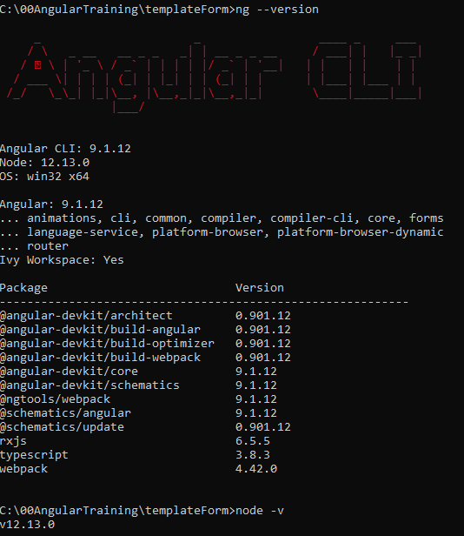

Preparation

1. Create New Angular Project
   1. ng new <project name>



* 1. ng serve

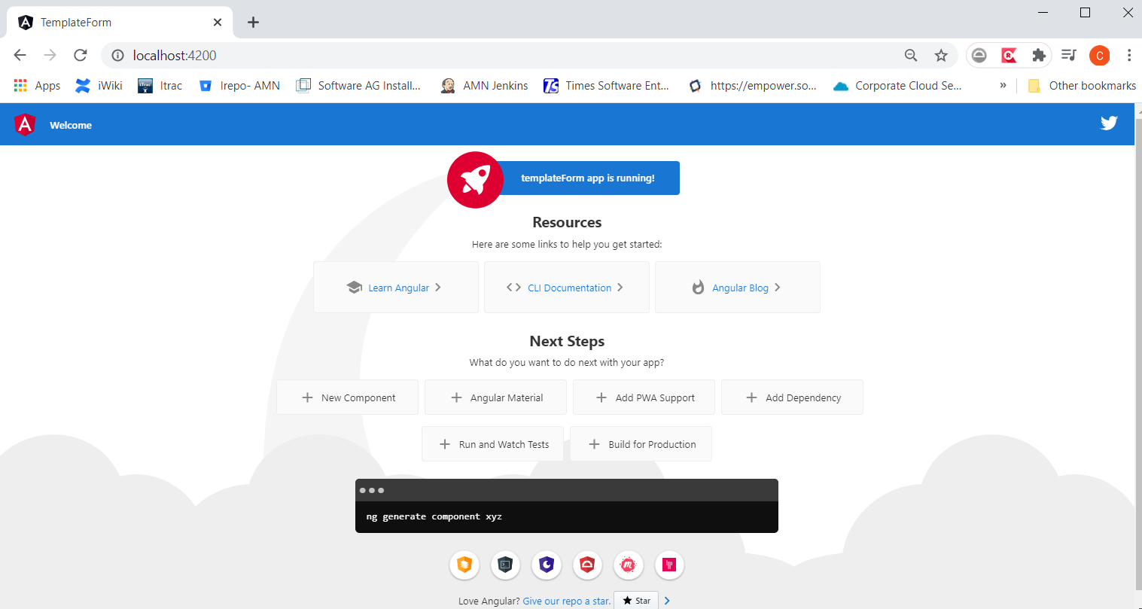

1. Add Bootstrap – add below into ./src/styles.css

@import url('https://unpkg.com/bootstrap@3.3.7/dist/css/bootstrap.min.css');

Exercise

1. Create HeroFormComponent – ng g c HeroForm
2. Import FormsModule into app.module.ts

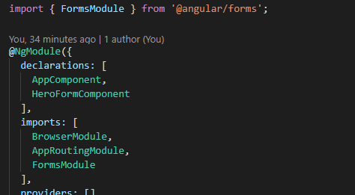

1. Make App component to render HeroFormComponent – Replace AppComponent’s content with “<app-hero-form></app-hero-form>”

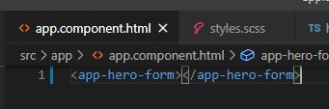

Note: Test your application with “ng serve” and you should able to get below

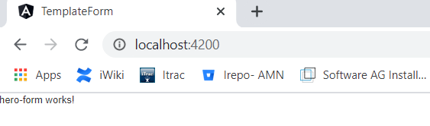

1. Create ./src/app/hero.ts file

export class Hero {

  constructor(

    public id: number,

    public name: string,

    public power: string,

    public alterEgo?: string

  ) {}

}

1. Update hero-form.component.html as below

export class HeroFormComponent {

  powers = ['Really Smart', 'Super Flexible', 'Super Hot', 'Weather Changer'];

  model = new Hero(18, 'Dr IQ', this.powers[0], 'Chuck Overstreet');

  onSubmit() {

    console.log('submitted', this.model);

  }

}

1. Update hero-form.component.ts as below

<h1>Hero Form</h1>

<form (ngSubmit)="onSubmit()" #heroForm="ngForm">

  <div class="form-group">

    <label for="name">Name</label>

    <input

      type="text"

      class="form-control"

      id="name"

      required

      [(ngModel)]="model.name"

      name="name"

      #name="ngModel"

    />

    <div [hidden]="name.valid || name.pristine" class="alert alert-danger">

      Name is required

    </div>

  </div>

  <div class="form-group">

    <label for="alterEgo">Alter Ego</label>

    <input

      type="text"

      class="form-control"

      id="alterEgo"

      [(ngModel)]="model.alterEgo"

      name="alterEgo"

    />

  </div>

  <div class="form-group">

    <label for="power">Hero Power</label>

    <select

      class="form-control"

      id="power"

      required

      [(ngModel)]="model.power"

      name="power"

    >

      <option \*ngFor="let pow of powers" [value]="pow">{{ pow }}</option>

    </select>

  </div>

  <<button class="btn" type="submit" [disabled]="!heroForm.form.valid">Submit</button>

</form>

1. Update hero-form.component.scss (or .css)

.ng-valid[required],

.ng-valid.required {

  border-left: 5px solid #42a948; /\* green \*/

}

.ng-invalid:not(form) {

  border-left: 5px solid #a94442; /\* red \*/

}

1. Test again your application

